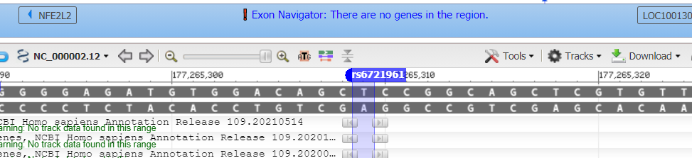

Start here on the reverse strand (read backwards) 5’-TGCCGG

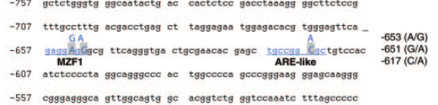

If you look at the flanking sequence from the FASEB paper it should match as the reverse strand of the Variation Viewer (top). Remember that the reverse (bottom) strand always reads from right to left.

5’-TGCCGG (C/A) GCTGT-3’ Jacqui

5’ TGCCGG (A) GCTGT-3’ Variation Viewer

So, dbSNP is referring to the top strand (sense, forward or top), which is T. In our data we read the bottom or antisense strand (so A) which is the same as the T variant allele for the top strand. We would now say G>>T for our SNP and that matches the dbSNP alleles. They have T>A / T>C / T>G based on the population being studied. Long story short, it’s the same SNP.

It all depends on the annotation, how you read the DNA. Forward, backwards, etc. Flanking sequence is crucial 😊